**Project Design Phase-I**

**Solution Architecture**

|  |  |
| --- | --- |
| Date | 19 September 2022 |
| Team ID | NM2023TMID08265 |
| Project Name | Aquatic Insights: Cognos -Powered Water Portability Analysis |
| Maximum Marks | 4 Marks |

**Solution Architecture:**

Solution architecture is a complex process – with many sub-processes – that bridges the gap between business problems and technology solutions. Its goals are to:

* Find the best tech solution to solve existing business problems.
* Describe the structure, characteristics, behavior, and other aspects of the software to project stakeholders.
* Define features, development phases, and solution requirements.
* Provide specifications according to which the solution is defined, managed, and delivered.

**Example - Solution Architecture Diagram:**

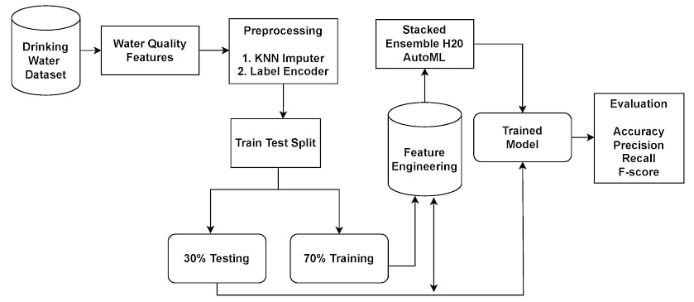

*Figure 1: Architecture and data flow of the voice patient diary sample application*

**Reference:**

**https://www.google.com/url?sa=i&url=https%3A%2F%2Fwww.mdpi.com%2F2073-4441%2F15%2F3%2F475&psig=AOvVaw3f30FXneK-wuf-6YxyJMSR&ust=1699373157335000&source=images&cd=vfe&opi=89978449&ved=0CBIQjRxqFwoTCLDcirzgr4IDFQAAAAAdAAAAABAE**